


BIAR – Supplementary FSD

Table of Contents
Fraud Detection Dataflow from Ingestion to Insights 2
User Stories 4
1. BIAR Module 4
DLH-1 Land immutable raw data in Apache Ozone using Apache Nifi 4
PIPE-1. Apache Spark processing with checkpoints 4
DLH-2. Create Bronze Apache Hudi (Copy-On-Write) tables with Apache Spark 4
DLH-3. Silver enrichment & schema evolution (Apache Hudi) 5
DLH-4. Curated Gold marts for BI/ML 5
PIPE-2a. Stream ingest (real-time) 5
PIPE-2b. Trickle ingest (small deltas) 6
PIPE-2c. Batch ingest (bulk backfill) 6
PIPE-3. ETL contract tests 6
PIPE-4. Operational monitoring & alerting 7
CIMS-1. Store and retrieve unstructured artifacts (CouchDB) 7
VEC-1. Store unstructured artifacts in a vector database 7
TIKA-1. Extract text and metadata from unstructured artifacts 8
SOLR-1. Index extracted metadata into Apache Solr 8
BI-1. JupyterHub multi-user access to Gold 8
ML-1. Real-time fraud detection with ensemble models 9

Fraud Detection Dataflow from Ingestion to Insights

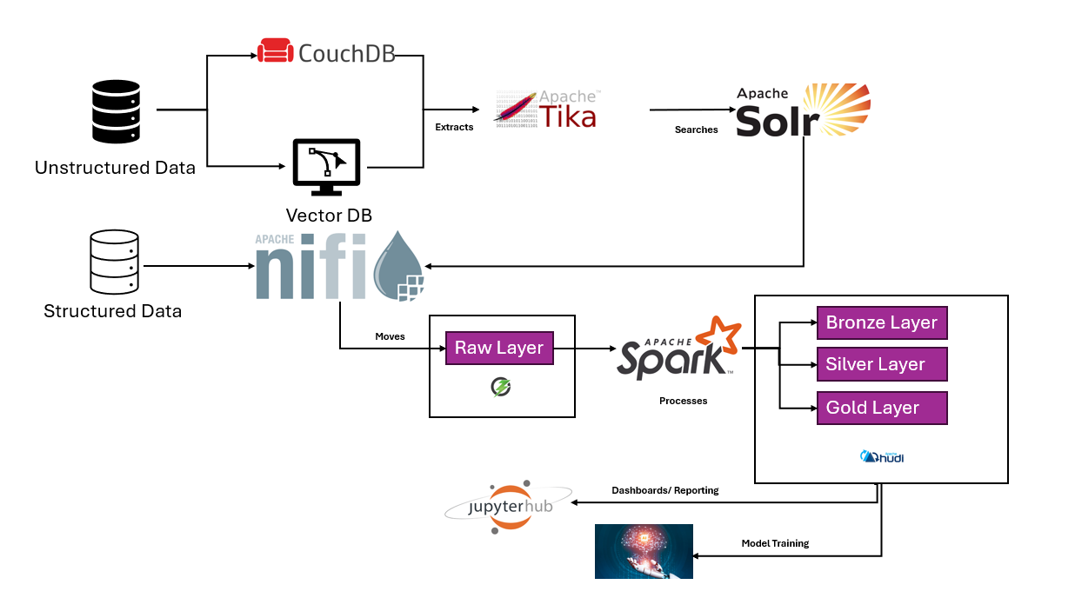

User Stories

1. BIAR Module

DLH-1 Land immutable raw data in Apache Ozone using Apache Nifi
As a Data Engineer, Set up a safe “inbox” in Apache Ozone where original CSV/JSON files arrive and never get changed. This lets us replay exactly what came in and prove integrity later.
Steps:
- Create a bucket/folder pattern like raw/<source>/dt=YYYY-MM-DD/.
- Use Apache NiFi to automatically drop incoming files into that folder (parameterized for re-use).
- Confirm files exist, record size + checksum, and verify lifecycle and audit logs are active.
Acceptance Criteria:
- File exists in the correct folder with size and checksum/metadata recorded.
- Lifecycle policy is visible in object metadata after its window elapses.
- Audit log shows who wrote what, where, when, including checksum and size

PIPE-1. Apache Spark processing with checkpoints
As a Data Engineer, Run Spark Structured Streaming with a durable checkpoint so restarts pick up where they left off and use UPSERT into Hudi for exactly‑once outputs.
Steps:
- Configure a checkpoint directory in object storage; write to Hudi with stable keys and preCombine.
- Kill and restart the job to prove it resumes from the last committed offset.

Acceptance Criteria:
  - Job resumes from the last committed offset after restart.
  - No duplicate business keys appear in Hudi outputs.

DLH-2. Create Bronze Apache Hudi (Copy-On-Write) tables with Apache Spark
As a Data Engineer, Build Bronze tables in Apache Hudi so we get database-like safety (ACID) on the Data Lakehouse: we can upsert rows cleanly and read only what changed.

Steps:
  - Write a Spark job that reads Raw and writes Hudi COW at ozone://lake/bronze/<domain> with record key, partition column, and preCombine (e.g., updated_at).
  - Run twice with a duplicate key to simulate an update and validate UPSERT behavior.
  - Read the latest snapshot, then “time‑travel” to an earlier commit and compare results
Acceptance Criteria:
  - Hudi table has a valid commit timeline.
  - Duplicate keys resolve to the newest record (UPSERT via preCombine).
  - Time‑travel returns the correct earlier view for the chosen instant.

DLH-3. Silver enrichment & schema evolution (Apache Hudi)
As a Data Engineer, Turn Bronze into standardized, enriched silver tables that can safely accept new columns and quarantine bad records to a Dead‑Letter Queue (DLQ).
Steps:
  - Add a new nullable column upstream and define Data Quality (DQ) rules.
  - Run Raw→Bronze→Silver with Hudi schema‑evolution enabled to apply standardization/enrichment.
  - Send DQ‑failed rows to a DLQ with clear reason codes, support incremental reads since instant T.

Acceptance Criteria:
  - Schema evolves without failure; older rows show null/default for the new column.
  - DLQ captures failed rows with reason and counts.
  - Incremental read since instant T returns only changed rows.

DLH-4. Curated Gold marts for BI/ML
As a Data Analyst, Build trusted Gold datasets so dashboards and models are fast and consistent.
Steps:
  - Create Gold models (Spark) with tests (unique, not‑null), column documentation, and freshness checks.
  - Users can connect Apache Superset; open representative dashboards and apply common filters.
  - Enforce Row‑Level Security (RLS) and Column‑Level Security (CLS) for different roles
Acceptance Criteria:
- All tests pass and columns are documented.

PIPE-2a. Stream ingest (real-time)
As a Data Engineer, I want to ingest data from NATS into Raw storage in near real-time so that events are available for downstream processing with minimal lag.
Steps
  - Connect NATS to Raw (Ozone).
  - Measure end-to-end ingestion lag.
  - Monitor performance under normal and peak load.

Acceptance Criteria
- Provenance confirms event arrival order and timestamps.
- Pipeline remains healthy under sustained throughput.

PIPE-2b. Trickle ingest (small deltas)
As a Data Engineer, I want to support trickle ingestion of small deltas via HTTP/SFTP so that frequent but lightweight updates are captured quickly.
Steps
  - Configure HTTP/SFTP source to drop deltas into Raw.
  - Parameterize for different tenants/domains.
  - Track delta arrival and append times.
Acceptance Criteria
  - Malformed files are routed to DLQ with error reason.
  - Provenance shows correlation ID and successful load.

PIPE-2c. Batch ingest (bulk backfill)
As a Data Engineer, I want to run scheduled batch jobs into Raw so that large historical datasets can be ingested without disrupting streaming workloads.
Steps
  - Schedule batch backfills (daily/weekly/monthly).- to be decided
  - Validate completeness of loaded data (record counts, checksums).
  - Monitor streaming performance during batch execution.
Acceptance Criteria
  - Checksums and counts match expected totals.

PIPE-3. ETL contract tests
As a Data Engineer, I want to enforce schema contracts and test transformations with golden datasets so that schema breaks and logic errors are caught early and do not reach production.
Steps
- Define schema contracts (required columns, types, validation rules).
- Create unit tests and golden datasets for key flows.
- Run CI/CD pipeline with contract tests.
- Deliberately break input schema or logic to simulate controlled failures.
- Verify errors are actionable, fix the issue, and re-run tests.

Acceptance Criteria
- Normal runs complete successfully.
- Contract tests fail fast with clear error messages when schema or rule violations occur.
- Golden dataset replays match expected checksums and outputs.

PIPE-4. Operational monitoring & alerting
As an Operator, I want full observability of pipeline metrics and automated alerting so that issues are detected quickly, escalated to on-call staff, and resolved reliably.
Steps
- Publish metrics (lag, error rate) from pipelines.
- Build dashboards to visualize metrics.
- Simulate outages to deliberately breach SLOs.
- Trigger alerts via monitoring system (e.g., PagerDuty, Slack).
- Follow the documented runbook to restore service.
- Validate end-to-end recovery after intervention.
Acceptance Criteria
- Dashboards show current lag, and error rates clearly.
- Runbook steps allow successful recovery end-to-end.
- Post-incident validation confirms system health and data integrity.

CIMS-1. Store and retrieve unstructured artifacts (CouchDB)
As a Case Manager, I want to store unstructured evidence (PDFs, images, emails) in CouchDB so that the exact original files are preserved securely while only metadata flows into the lake.
Steps
- Create a case document and upload an attachment (PDF/image/email).
- Fetch the attachment to verify exact bytes and checksum/content-type.
- Extract metadata into JSON and send it to Lakehouse Raw.
- Ensure binaries remain stored only in CouchDB.
Acceptance Criteria
- Upload creates a new CouchDB revision/ETag.
- Fetch returns the original bytes with correct checksum and MIME type.
- Only metadata is sent to the lakehouse; binary artifacts remain in CouchDB.

VEC-1. Store structured artifacts in a vector database
As an Investigator, I want vector embeddings of raw data stored in a vector database so that I can run semantic similarity searches over case evidence.
Steps
- Generate embeddings (e.g., from extracted text via Tika or directly).
- Store vectors + metadata in OpenSearch or a dedicated vector DB.
- Run k-NN queries and validate retrieval accuracy.
Acceptance Criteria
- All ingested artifacts have corresponding vectors with metadata (case ID, source).
- Deleted artifacts also remove their vectors.

TIKA-1. Extract text and metadata from unstructured artifacts
As a Data Engineer, I want Apache Tika to process PDFs, images, and emails so that plain text and metadata are available for downstream indexing.
Steps
- Upload a binary artifact (PDF, image, email) to CouchDB.
- Run Apache Tika to detect content type and extract text + metadata.
- Package extracted output in JSON format for downstream use.
Acceptance Criteria
- Extracted text and metadata JSON are generated for all supported file types.
- Metadata includes case ID, type, timestamps, and checksum.
- Extraction failures are logged with reason codes in a DLQ or error collection.

BIAR-1. Ingest the extracted metadata to Raw Layer
As a Data Engineer, I want to extract text and metadata from unstructured artifacts and ingest it into the Raw layer so that downstream systems can index, search, and analyze evidence without directly accessing the binaries.
Steps
- Listen for new or updated CouchDB documents with attachments.
- Use Apache Tika to extract text and metadata (case ID, timestamps, mime type, checksum).
- Package extracted output as JSON and land it in Raw (raw/case/dt=YYYY-MM-DD/).
- Route failed extractions to a DLQ with error reason and correlation ID.
Acceptance Criteria
- Metadata JSON is successfully created for each ingested artifact.
- Metadata contains required fields (case ID, type, timestamps, checksum).
- Extraction failures are logged in DLQ with clear reason codes.
- No binary content is written to Raw (only JSON).

SOLR-1. Index extracted metadata into Apache Solr
As an Investigator, I want metadata and extracted text ingested into Solr so that I can search and filter evidence effectively.
Steps
- Take JSON output from Tika extraction.
- Index into a Solr core with searchable fields (case ID, type, timestamps, extracted text).
- Validate ingestion time from artifact upload to Solr visibility.
Acceptance Criteria
- All metadata fields are searchable and facetable.
- Ingestion errors are logged and retriable.

BI-1. JupyterHub multi-user access to Gold
As a Data Analyst, I want a private JupyterHub notebook server with secure access to Gold datasets so that I can analyze curated data without risk of modifying it.
Steps
- Configure OAuth authentication and spawn per-user notebook servers with required kernels.
- Mount read-only connections to Gold datasets using vaulted secrets.
- Run a sample notebook and export results to HTML/PDF.
Acceptance Criteria
- A private notebook server spins up for each user with correct kernels.
- Read-only access to Gold is enforced; write access is blocked.
- Sample notebooks execute successfully and can export to standard formats.

